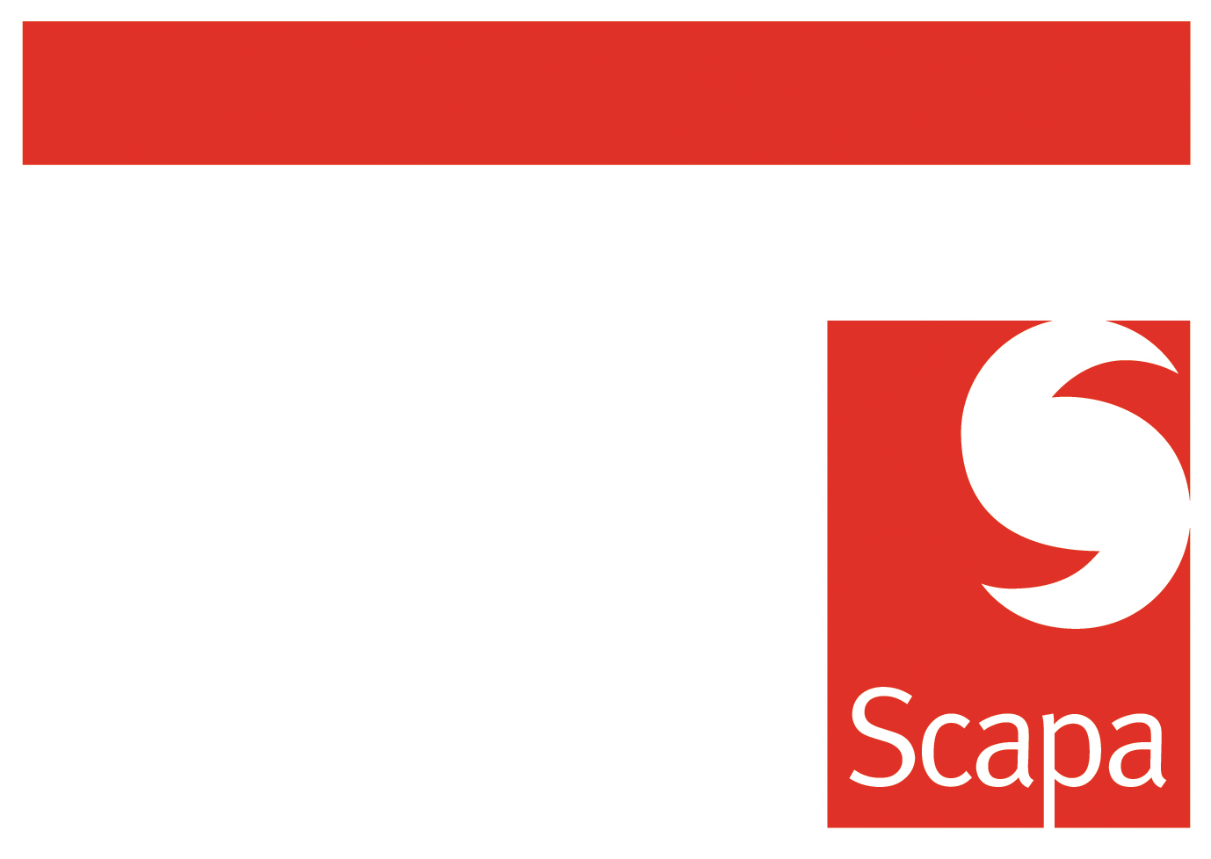

Technical Audit Document

- OVERVIEW

MARKET SECTOR
Company name
Manufacturer of
Address
Country
Date of audit
Audit stakeholders :  Customer | Name | Title | Tel &/or email
Audit stakeholders :  Scapa | Name | Title
Audit related to : (describe application)

Potential (quantities/year –turnover/year)

Audit leader

Distribution list

- APPLICATION

In bold : compulsory information

What is the application ?
What is the end use of the finished product ?
What are the tape’s functions ? (Resist UV, high temperature resistance, bond low surface energy substrates, clean peel after application, high static shear require, etc….)
Substrates to be bonded  For plastics, give chemical nature (e.g. polypropylene) | Substrate 1 :  Substrate 2 :
Rough or smooth surface ? | Substrate 1 :  Substrate 2 :
Surface shape (flat, curved )
Any surface treatment ?
(corona, plasma, chemical, primer)
Joint design
(overlap, butt)
Is it a permanent or removable application ?
Is it an indoor or outdoor application ?
Any performance specification to comply to ?
If yes please mention number and/or get a copy
What kind of stress the tape will be submitted to : shear (static/dynamic), peel, cleavage, pull/push ?
Please indicate loading if known
What temperature will the tape be exposed to ?
What level of humidity will the tape be exposed to ?
Will the tape be in contact with chemical products ?
If yes, please indicate the level of contact and duration
Will the tape be exposed to UV light ?
If yes, please indicate the side of contact (through adhesive or through carrier) and duration
Fire-retardancy requested ?
If yes and known mention the norm
If application has been seen, additional comment

- COMPETITOR INFORMATION

In bold : compulsory information

What medium are you currently using for your application ? (Liquid adhesive, adhesive tape, mechanical fastener)
Product detail (brand, reference, dimensions)
What are the current issues with your existing product in your application ?

What would you like to improve in your application ?

- PRESENTATION REQUIREMENTS

In bold : compulsory information

Do you require : rolls, spools, pads, bags (for cable market) ?

Width required / tolerances

Length required / tolerances

Weight of bags (for cable market)

For pads, is there a drawing available ?
Diameter and nature of the core
Scapa / neutral / private label core ?
Is there a maximum outside diameter / width / weight ?
Splice allowed ?
if yes indicate the splice type and the number of splice allowed per roll
If product we supplied is converted, what type of conversion ? What final format of the product is made ?
Fingerlift liner ?
If yes, indicate if one side/two sides and width

- PROCESS REQUIREMENTS

Manual or automatic process ?

Description
What are the performance criteria you require from an adhesive tape in your application ? (stay flat, high grab, unwind force, non polluting, etc)

- SAFETY AND ENVIRONNEMENT

Any substances banned/restricted in the product ?
Any regulation to comply with (EU directives, medical regulation….)
Any other requirements ?

- QUALITY

Do you require an approval such as, UL, VDE, BS, DIN…. ?
If yes, please detail
Do you require our product to be made in ISO 9001 and/or TS 16946 and/or ISO 14001 facility ?
Is there any quality documentation to be completed ?
Is there a specification for quality rejection (ppm of non-conforming product delivered) ?
Do you require a product quality specification to be signed ?

- PRICING /TIMING /COMMERCIAL DETAILS

In bold : compulsory information

Pricing parameters
Annual volume
What is the timeline for :
- Samples
- Product to be commercialised
What other options are you considering as a solution for this application ?
Single source, dual source policy ?
In case of dual source, % of business shared between the two suppliers

9. DOCUMENTS

Information available | yes | no
Technical specifications :
Testing method(s) :
Testing report(s) :
Samples of substrate(s) to bond :
Current product(s) sample(s) :
Other documents :
Documents detail

END OF THE DOCUMENT

